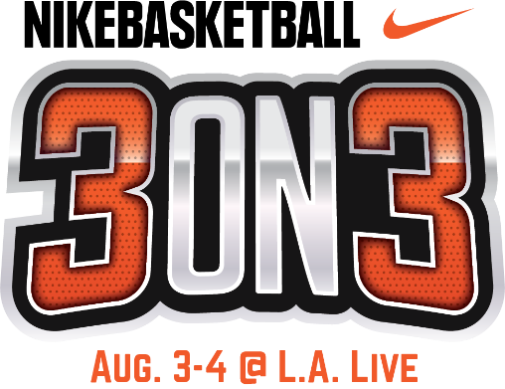

FREE OPENING NIGHT CEREMONY & TIP OFF PARTY TO KICK OFF
11TH ANNUAL NIKE BASKETBALL 3ON3 TOURNAMENT WEEKEND
DURING DOWNTOWN DARK NIGHTS AT L.A. LIVE;
FRIDAY, AUG. 2

WHAT: The 11th Annual Nike Basketball 3ON3 Tournament at L.A. LIVE will kick off with a tournament first: a FREE Opening Night Ceremony and Tip Off Party during a special edition of Downtown Dark Nights at L.A. LIVE. The FREE outdoor event will feature Pep Rally-type activities, music, pop-up shops, street performers, live art and food and drink specials at select L.A. LIVE restaurants. Guests will also be able to participate in “Pay to Play” opportunities on center court competing in various basketball challenges such as knockout competitions, half court shots, free throws, etc. in addition to a Spartan Race Obstacle Course located on Chick Hearn Court.

Nike Basketball 3ON3 Tournament, which this year will serve as an official International Basketball Federation (FIBA) 3X3 Satellite Tournament for the Men’s Elite Division, is expected to feature more than 1,500 teams, 5,000 players, and 25,000 spectators throughout the weekend. Tournament play will run from Saturday, Aug. 3 – Sunday, Aug. 4.

The Nike Basketball 3ON3 Tournament is free and open to the public to attend. The weekend will feature a variety of events at the Nike Center Court located within Xbox Plaza at L.A. LIVE, including the highly anticipated Nike Slam Dunk Contest on Saturday afternoon, a 3-Point Contest, Skills Challenge in addition to more than 15 interactive vendors and basketball-themed activities.

WHERE: L.A. LIVE
800 West Olympic Blvd,
Los Angeles, 90015
*Basketball Activities to take place on Center Court in Xbox Plaza

WHEN: Friday, August 2, 2019
6-11 p.m.

TO COVER: Please contact Allegra Batista, abatista@aegworldwide.com, (213) 763-7738.
Media assets for the Tournament will be available at: https://www.aegworldwide.com/press-center/media-assets

