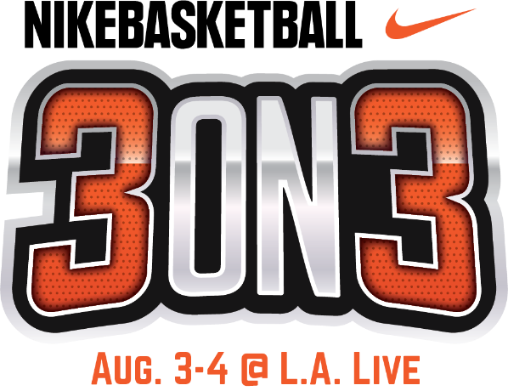

NIKE BASKETBALL 3ON3 TOURNAMENT RETURNS TO L.A. LIVE; TO SERVE AS AN OFFICIAL FIBA 3X3 SATELLITE TOURNAMENT

FREE Opening Night Ceremony and Tip Off Party to Kick Off California’s Largest
3-on-3 Street Basketball Tournament; Friday, August 2

LOS ANGELES (July 15, 2019) – Nike Basketball 3ON3 Tournament, California’s largest street basketball tournament, now in its 11th year, will return to the streets of downtown Los Angeles and L.A. LIVE on Saturday, August 3 - Sunday, August 4. The annual family-friendly basketball weekend will kick off with an opening night ceremony and tip off party on center court as part of Downtown Dark Nights at L.A. LIVE. This FREE outdoor event features Pep Rally-type activities, music, pop-up shops, street performers, live art, and more on Friday, August 2 from 6-11 p.m.

Nike Basketball 3ON3 Tournament, which will serve as an official International Basketball Federation (FIBA) 3X3 Satellite Tournament, is expected to feature more than 1,500 teams, 5,000 players, and 25,000 spectators. As the official Satellite Tournament, airfare, lodging, transportation and food allowance will be provided to the winning Men’s Elite Team to the FIBA 3X3 Challenger Event in Edmonton on September 28-29. Winners of the Edmonton Challenger will have a chance to win $20,000 in prize money and advances to the FIBA 3X3 World Tour Nanjing Masters in China on October 12 and 13.

Registration for the tournament is open to players of all ages and skill levels at nike3on3.com. Athletes are encouraged to sign up as soon as possible as brackets fill up quickly. Three-on-three tournament games will take place on approximately 100 outdoor basketball courts with interactive vendors and basketball-themed activities throughout the L.A. LIVE campus.

The tournament features six main divisions of play: Adult Elite Division presented by Nike Basketball, Adult Division presented by US Army, Teen Division presented by Big 5 Sporting Goods, Youth Division presented by Blue Shield of California, Special Olympics Division and Wheelchair Division. The Nike Elite Division will consist of two categories of players: Women’s and Men's. Wheelchair and Special Olympics teams of all ages and abilities are encouraged to play and game schedules will be based on the level of participation. Teams can register their teams online at nike3on3.com.
Complete team registration for the Nike Basketball 3ON3 Tournament starts at $200 for the Youth division (ages 8-9 and ages 10-12), $200 for the Teen division (ages 13-19), $220 for the Adult division (ages 20 and over) and $260 for the Adult Elite division (ages 18 and over). Athletes of all ages and skill levels are invited to play. Each team must have a minimum of three players and a maximum of four players to participate. Registration for Special Olympics and Wheelchair divisions is open to all ages and is free of charge. Teams can register by visiting nike3on3.com

As the largest 3-on-3 basketball tournament in California, Nike Basketball 3ON3 Tournament has continued to partner with leading brands in the sports industry. Official sponsors of the Nike Basketball 3ON3 Tournament include Nike Basketball, Big 5 Sporting Goods, Powerade, US Army, Spartan Race, Blue Shield of California, Budweiser, Tequila Avión, Jameson Whiskey, and Martell Cognac.

The Nike Basketball 3ON3 Tournament is free and open to the public to attend. The three-day experience will feature a variety of events at the Nike Center Court located within Xbox Plaza at L.A. LIVE, including the highly anticipated Nike Slam Dunk Contest, a 3-Point Contest, Skills Challenge in addition to more than 15 interactive vendors and basketball-themed activities. To participate in playing in the tournament, complete information about registration, eligibility, rules and bracketing can be found at the official Nike Basketball 3ON3 Tournament website, Nike3on3.com. For additional information and up to the minute details, follow the official Twitter account at twitter.com/nikebball3on3, the official Facebook page at facebook.com/nike3on3 and the official Instagram account at @nike3on3.

About L.A. LIVE
L.A. LIVE is a 4 million square-foot, $3 billion downtown Los Angeles sports and entertainment district adjacent to STAPLES Center and the Los Angeles Convention Center featuring The Novo, a 2,300 capacity live music venue, Microsoft Theater, a 7,100-seat live theatre, a 54-story, 1001-room convention “headquarters” destination (featuring The Ritz-Carlton, Los Angeles and JW Marriott Los Angeles at L.A. LIVE hotels and 224 luxury condominiums – The Ritz-Carlton Residences at L.A. LIVE – all in a single tower), the GRAMMY Museum, the 14-screen Regal L.A. LIVE: A Barco Innovation Center theatre, broadcast facilities for ESPN along with entertainment, residential, restaurant and office space.

Developed by Los Angeles-based AEG, L.A. LIVE, considered to be the nation’s most active ‘live content and event campus,’ has become the region’s most in-demand and busiest hospitality location throughout the past 10 years, featuring 260,480 sf of conference center and ballroom facilities, world-class restaurants including WP24, Fleming’s Prime Steakhouse & Wine Bar, Katsuya, Shaquille’s, Rock ‘N Fish, Rosa Mexicano, Starbucks, Glance Restaurant, Smashburger, Live Basil Pizza, Tom’s Urban 24, Yard House, Wolfgang Puck Bar & Grill and BOCA at the Conga Room and others; 100,000 sf special events deck, the famous Lucky Strike Lanes and Lounge, the celebrity owned Conga Room, a one-of-a-kind GRAMMY Museum, saluting the history of music and the genre’s best known awards show all centered around Xbox Plaza, a 40,000 sf outdoor event space.

With Microsoft Theater and Xbox Plaza which came on-line in October, 2007, and the hotel, residential and meeting space components opened as of April, 2010 combined with the assets, resources and infrastructure of STAPLES Center and the Los Angeles Convention Center, L.A. LIVE showcases more events, award shows, sporting competitions, concerts and hospitality options than any other destination in the world.

# # #
Media Contacts:
Allegra Batista
(213) 763-7738
abatista@aegworldwide.com

