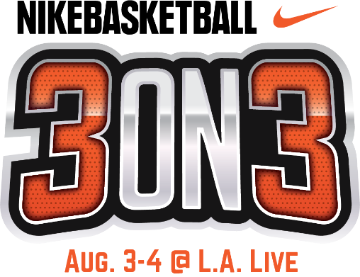

NIKE SLAM DUNK CONTEST TO TAKE
11TH ANNUAL NIKE BASKETBALL 3ON3 TOURNAMENT AT L.A. LIVE
TO NEW HEIGHTS; SATURDAY, AUG. 3

California’s Largest 3x3 Street Basketball Tournament to Feature

More than 5,000 basketball players and 1,500 teams; Aug. 3-4

WHAT: The Nike Slam Dunk Contest is back by popular demand for the 11th Annual Nike Basketball 3ON3 Tournament at L.A. LIVE. A fan-favorite for both athletes competing in the tournament and spectators alike, professional slam dunkers will defy gravity on the main court in L.A. LIVE’s Xbox Plaza to perform their signature slam dunks – including potentially leaping over a few fans and props in the process!

Nike Basketball 3ON3 Tournament, which this year will serve as an official International Basketball Federation (FIBA) 3X3 Satellite Tournament for the Men’s Elite Division, is expected to feature more than 1,500 teams, 5,000 players, and 25,000 spectators throughout the weekend. Tournament play will run from Saturday, Aug. 3 – Sunday, Aug. 4.

The Nike Basketball 3ON3 Tournament is free and open to the public to attend. The weekend will feature a variety of events at the Nike Center Court located within Xbox Plaza at L.A. LIVE, including a 3-Point Contest, Skills Challenge in addition to more than 15 interactive vendors and basketball-themed activities throughout the Fan Fest.

WHERE: L.A. LIVE’s Xbox Plaza
800 West Olympic Blvd,
Los Angeles, 90015

WHEN: Saturday, August 3, 2019
2-3 p.m. Nike Slam Dunk Contest
9 a.m. – 5 p.m. Tournament Play on 100 courts surrounding STAPLES Center & L.A. LIVE

TO COVER: Please contact Cassandra Zebisch, czebisch@aegworldwide.com, (213) 763-7712
Photos and media assets for the Tournament and Slam Dunk Contest will be available at: https://www.aegworldwide.com/press-center/media-assets

