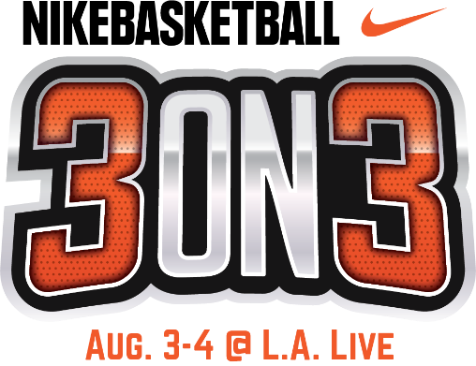

OLYMPIC HOPEFULS TO LEAVE IT ALL ON THE COURT
IN MEN AND WOMEN’S NIKE ELITE DIVISION FINALS; TO CONCLUDE
11TH ANNUAL NIKE BASKETBALL 3ON3 TOURNAMENT AT L.A. LIVE;
SUNDAY, AUG. 4

Weekend play to conclude for more than 5,000 basketball players

in California’s largest 3x3 street basketball tournament

WHAT: The 11th Annual Nike Basketball 3ON3 Tournament, California’s largest 3x3 street basketball tournament, will conclude at L.A. LIVE with the men and women’s Nike Elite Division finals; which also will serve as qualifiers for the FIBA Edmonton Challenger (for the men’s division) and the Women’s Regional USA Basketball Tournament in Los Angeles.

In a Tournament first, the Nike Basketball 3ON3 Tournament, served as an official International Basketball Federation (FIBA) 3X3 Satellite Tournament for the Men’s Elite Division, with the winners guaranteed entry into FIBA’s upcoming Edmonton Challenger; there the team can ultimately qualify to advance to the FIBA 3X3 World Tour Nanjing Masters in China – bringing them one step closer to representing the USA in the 2020 Olympics during the debut of 3x3 basketball.

Throughout the weekend, more than 5,000 players competed on the surrounding streets of L.A. LIVE and STAPLES Center throughout downtown Los Angeles in California’s largest 3-on-3 street basketball tournament, with more than 25,000 fans and spectators cheering them on.

WHERE: L.A. LIVE’s Xbox Plaza
800 West Olympic Blvd,
Los Angeles, 90015

WHEN: Sunday, August 4, 2019
9 - 11 a.m. Nike Basketball 3ON3 Scouts Clinic
9 a.m. to 4 p.m. Tournament Play + Fan Fest
4-5 p.m. Nike Elite Division Finals
*4-4:30 p.m. Women’s Nike Elite Division Finals
*4:30-5 p.m. Men’s Nike Elite Division Finals

TO COVER: Please contact Cassandra Zebisch, czebisch@aegworldwide.com, (213) 763-7712
Photos and media assets for the Tournament and Slam Dunk Contest will be available at: https://www.aegworldwide.com/press-center/media-assets

