**FOR IMMEDIATE RELEASE**

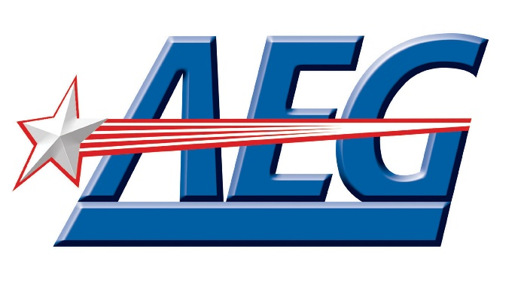

**AEG Community Foundation Awards $400,000**

**in Grants to 20 Nonprofits Across the U.S.**

[*Download photos here*](https://aegworldwide.com/press-center/media-assets)

**Los Angeles, CA (August 25, 2025)** – AEG, the world’s leading sports and live entertainment company, today announced that 20 nonprofit organizations across the United States will receive grants $400,000 from the AEG Community Foundation. The grants, ranging from $15,000 to $25,000, will support programs focused on K-12 education, the arts, and health and wellness in the communities where AEG and its partners operate.

Several of this year’s grant recipients were nominated by AEG employees who have previously collaborated with or supported these organizations, highlighting their meaningful impact at the local level. Each nomination was carefully reviewed by the Foundation’s national executive board, which selected the final recipients based on their demonstrated commitment to building stronger, healthier, and more equitable communities.

“For 25 years AEG has invested in non-profit organizations that make a meaningful difference in underserved communities with a goal of helping these communities thrive,” said Martha Saucedo, Chief External Affairs Officer, AEG. “The grants being awarded today by the AEG Community Foundation will support the valuable work these nonprofits do every day to uplift and empower the people they serve.”

"We are profoundly grateful to the AEG Community Foundation for their generous $20,000 grant supporting our Hope Street Margolis Family Center After-School Program," says Susan Shum, California Hospital Medical Center Foundation Chief Philanthropy Officer and AEG grantee. "This isn't just funding; it's an investment in our Hope Street families, supporting their success, creative outlets and healthier futures. This grant will empower us to continue fostering vital math and English skills, ignite curiosity through science, technology, engineering, arts and math (STEAM), and provide holistic support, ensuring our children not only succeed in school but thrive in life. Together, with partners like AEG, we are building a stronger, more resilient community, one bright future at a time."

**The recipients of the AEG Community Foundation 2025 Grant Cycle include:**

**K-12 Education**

* BOSS, Inc. (Long Beach, CA)
* Little Tokyo Service Center (Los Angeles, CA)
* All People Community Center (Los Angeles, CA)
* Boys & Girls Club of Carson (Carson, CA)
* Big Brothers Big Sisters of Southeast Michigan (Ypsilanti, MI)
* California Science Center Foundation (Los Angeles, CA)
* City Year New York (New York, NY)
* California Hospital Medical Center Foundation (Los Angeles, CA)
* Central American Resource Center – CARECEN (Los Angeles, CA)

**Arts**

* Girls Write Nashville (Nashville, TN)
* Heart of Los Angeles (Los Angeles, CA)
* A Place Called Home (Los Angeles, CA)
* The Troy Andrews Foundation (New Orleans, LA)
* Inner-City Arts (Los Angeles, CA)
* Youth on Record (Denver, CO)
* Santa Barbara Bowl Foundation (Santa Barbara, CA)
* Alianza Coachella Valley (Coachella, CA)
* Angelica Center for Arts and Music (Los Angeles, CA)

**Health and Wellness**

* Olive Crest (Las Vegas, NV)
* YMCA of Metropolitan Los Angeles (Los Angeles, CA)

“This support is about opening doors for young people and fueling the future of Colorado’s music scene. Our students at Youth on Record are the ones who will carry music and live events forward in Denver and beyond. AEG’s backing helps us connect them to real jobs and internships, and it gives them the shot they deserve to make that vision real.” - Jami Duffy, Youth on Record Executive Director & the UMS Co-Manager

“We are deeply grateful to AEG for investing in the future of our youth”, said BBBSSEM Director of Programs, Dr. Joselyn Mitchell-Parker. “This grant is more than funding; it is a statement that the brilliance, leadership, and potential of young people in Southeast Michigan is seen, valued, and worth cultivating. With AEG Community Foundation’s support, our Leadership Camp will continue to empower these students to step into their power, lead with intention, and imagine a world they are fully capable of shaping."

“AEG was the first to believe in BOSS, and that belief has been transformative. Their early, and continued support hasn’t just open doors—its ignited a movement that’s empowering our boys to lead, achieve, and thrive.” BOSS, Inc. founder Everett GlennBOSS INC

**About AEG**

Headquartered in Los Angeles, California, AEG is the world’s leading sports and live entertainment company. The company operates in the following business segments:

* Music through AEG Presents, which is dedicated to all aspects of live

contemporary music performances, including the production and promotion of global and regional concert tours, an extensive portfolio of clubs, theaters and other music venues, concerts and special events and world-renowned festivals such as the Coachella Valley Music and Arts Festival;

* Venues and Real Estate, which develops, owns and operates world-class venues,

as well as major sports and entertainment districts like Crypto.com Arena and L.A. LIVE, Uber Platz in Berlin and The O2 in London;

* Sports, as the world’s largest operator of high-profile sporting events and sports

franchises including the LA Kings, LA Galaxy and Eisbären Berlin;

* Global Partnerships, which oversees worldwide sales and servicing of

sponsorships including naming rights, premium seating, and other strategic partnerships.

* And Ticketing, through its AXS.com ticketing platform, which provides more

than 400 clients worldwide with ticketing services that cover the gamut of entertainments, including sporting events, arena tours, music clubs festival, rodeos and family events.

Through its worldwide network of venues, portfolio of powerful sports and music brands and its integrated entertainment districts, AEG entertains more than 90 million guests annually. More information about AEG can be found at [www.aegworldwide.com](https://cts.businesswire.com/ct/CT?id=smartlink&url=http%3A%2F%2Fwww.aegworldwide.com&esheet=53421187&newsitemid=20230615362573&lan=en-US&anchor=www.aegworldwide.com&index=2&md5=13db3b8a7f20f5821352945ed9f15bb5).

###

Media Contact:

Jillian Salas; jisalas@aegworldwide.com